SHRI PANCHAM KHEMRAJ MAHAVIDYALAYA, SAWANTWADI
DEPARTMENT OF COMPUTER SCIENCE
PRACTICAL NO. : 1 | ROLL NO. : | TCS-513
SUBJECT: Computer Network | CLASS : | TYCS
AIM : Using Windows-cmd, execute following networking commands and note the output:  ping, traceroute, netstat, arp, ipconfig | DATE : | / / 2025
SOFTWARE USED : Cisco Packet Tracer | TEACHER SIGNATURE

- IpConfig

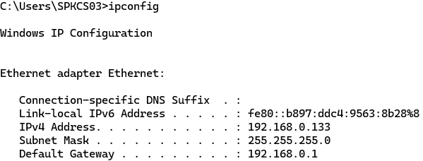

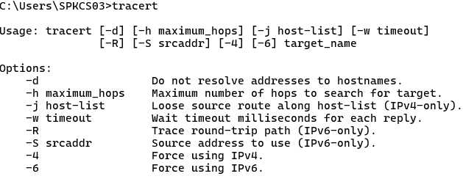
- Tracert

3) Netsat

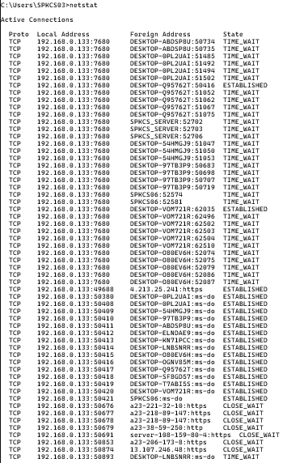

4) arp
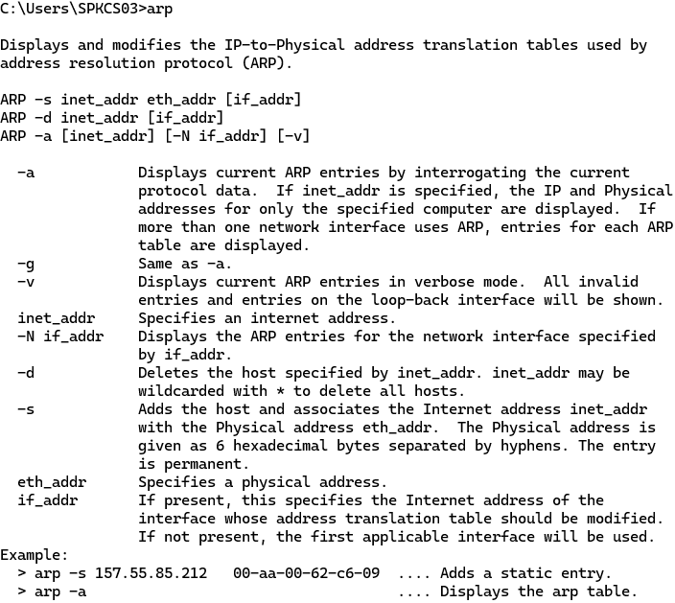

5) ping
